🧠 My Spring Boot Notes

🔧 Core Framework
- Spring Boot Starter – Auto-config, embedded server, entry point.
- Application Class – @SpringBootApplication, bootstrap logic.
- Properties & Profiles – application.yml, @Profile, environment config.
- Project Structure – Recommended package layout: controller, service, repository, entity, mapper, dto, config, db, resources, static, templates, test, .mvn.

📦 Build & Dependency Management
- Maven & pom.xml – Common dependencies:
- spring-boot-starter-*
- mapstruct, lombok, jakarta.validation
- spring-boot-starter-data-jpa, flyway-core
- Compiler plugin for MapStruct
- Maven commands: clean, install, package, spring-boot:run

🧭 API Layer
- Controllers – @RestController, @RequestMapping, @GetMapping, etc.
- DTOs – API contracts, separation from entities.
- Validation – @Valid, @NotNull, @Size, custom validators.
  - Controller–DTO–Service Flow
  - Strategic Audit Tips

🛠️ Service Layer
- Service Classes – @Service, orchestration logic.
- Dependency Injection & IoC – @Autowired, constructor injection, loose coupling, inversion of control.
  - Service Layer in the Request Lifecycle
  - Strategic Audit Tips

🗃️ Persistence Layer
- Repositories – @Repository, Spring Data JPA, query methods.
- Entities – @Entity, field mappings, relationships.
- Hibernate – ORM engine under JPA, lazy/eager loading, caching.
- JPA Config – @EnableJpaRepositories, schema generation.
- Flyway – DB migration tool, versioned SQL scripts in /db/migration.

🔄 Mapping & Conversion
- MapStruct – @Mapper, @Mapping, @MappingTarget, DTO ↔ Entity.
- Jackson – @JsonProperty, @JsonIgnore, serialization control.

🔐 Security & Governance
- Spring Security – AuthN/AuthZ, filters, roles.
- Audit Logging – Interceptors, listeners, structured logs.
- Exception Handling – @ControllerAdvice, @ExceptionHandler.

🧪 Testing & Debugging
- Unit Tests – JUnit, Mockito, @WebMvcTest, @DataJpaTest.
- Integration Tests – @SpringBootTest, test containers.
- Logging – SLF4J, Logback, MDC, structured output.

🚀 DevOps & Delivery
- Actuator – /actuator, health, metrics, info.
- Dockerization – Dockerfile, containerized Spring Boot.
- CI/CD Pipelines – GitHub Actions, Jenkins, deployment flow.

🏷️ Annotation Index
- Annotations Reference – Cross-cutting index of key annotations:
              - @SpringBootApplication, @RestController, @Service, @Repository
              - @Entity, @Table, @Id, @GeneratedValue
              - @Autowired, @Qualifier, @Value
              - @Valid, @NotNull, @Size
              - @Mapper, @Mapping, @MappingTarget
              - @JsonProperty, @JsonIgnore
              - @Transactional, @ControllerAdvice, @ExceptionHandler

🧾 Conceptual Overview Page
- Spring Boot Ecosystem Overview – Visual map of how everything fits:
              - Spring Boot: orchestration engine
              - JPA: persistence abstraction
              - Hibernate: ORM engine
              - Flyway: DB migration
              - DTOs + MapStruct: clean API contracts
              - Jackson: JSON serialization
              - Repositories: data access
              - Entities: domain models
              - Beans: managed components
              - Thymeleaf: templating (if using MVC)
              - REST: API transport layer

🛠️ Java Overview
- Collections
- Dates
- Strings
- Recursion

🔧 Core Framework

1. Spring Boot Starter
- Purpose: Auto-configures your app with sensible defaults.
- Key Feature: Embedded Tomcat, Jetty, or Undertow server.
- Common Starters:
  - spring-boot-starter-web – REST APIs
  - spring-boot-starter-data-jpa – JPA/Hibernate
  - spring-boot-starter-validation – Bean validation
  - spring-boot-starter-security – AuthN/AuthZ
- Governance Cue: Starters define your app’s operational scope. Audit them like dependencies.

2. Application Class
- Location: Root of your main package.
- Annotation: @SpringBootApplication = combo of:
  - @Configuration – Marks the class as a source of bean definitions.
  - @EnableAutoConfiguration – Enables Spring Boot’s auto-config magic.
  - @ComponentScan – Scans for @Component, @Service, @Repository, etc.
- Main Method:
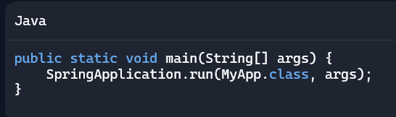
- Governance Cue: This is your bootstrap zone. Audit startup behavior here—especially for unexpected bean loading or config overrides.

3. Properties & Profiles
- Files: application.properties or application.yml
- Profiles:
  - application-dev.yml, application-prod.yml
  - Activate via spring.profiles.active=dev
- Common Configs:
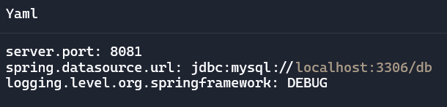
- Governance Cue: Profiles = environment boundaries. Audit config drift across them. Validate secrets, ports, and DB URLs per profile.

4. Project Structure
Here’s a recommended layout for audit-grade clarity:
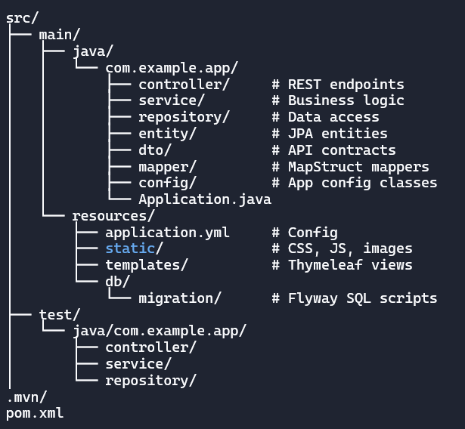
- Governance Cue: Structure reflects domain boundaries. Audit for separation of concerns, onboarding clarity, and test coverage alignment.

📦 Build & Dependency Management

5. Maven & pom.xml Overview
- Purpose: Maven manages dependencies, builds, and plugins.
- Key File: pom.xml (Project Object Model)
- Structure:
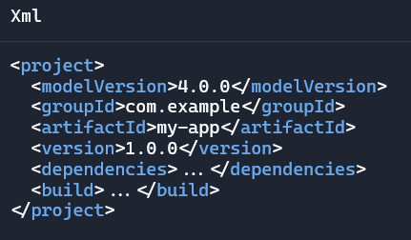
- Governance Cue: pom.xml is your dependency ledger. Audit it for version drift, plugin conflicts, and transitive bloat

Common Dependencies
Here are strategic inclusions for a Spring Boot backend:
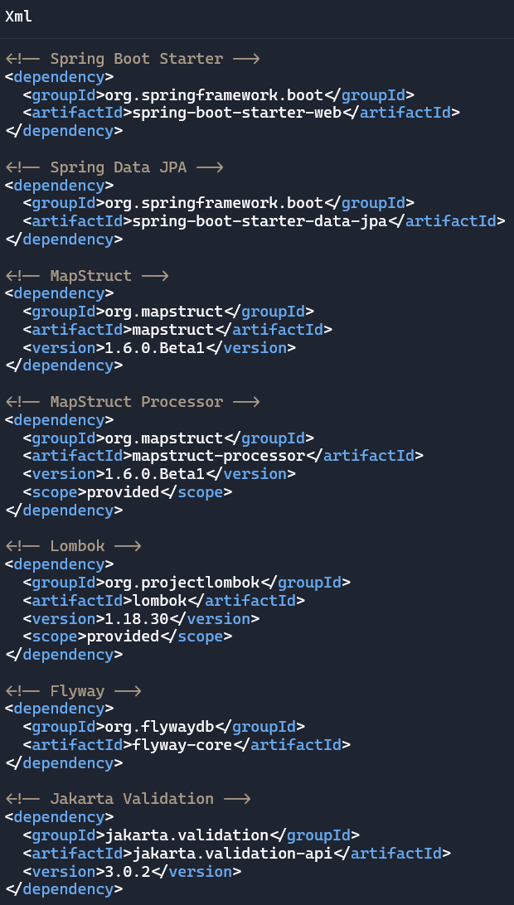

Compiler Plugin for MapStruct
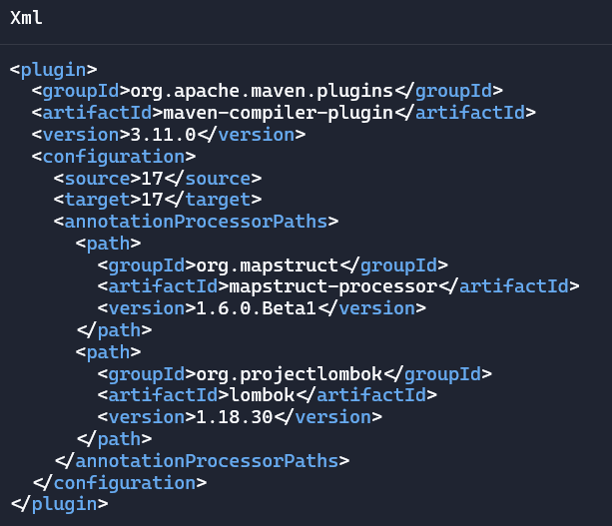

Governance Cue: Compiler plugins define build-time behavior. Audit for annotation processing and Java version alignment.

Common Maven Commands
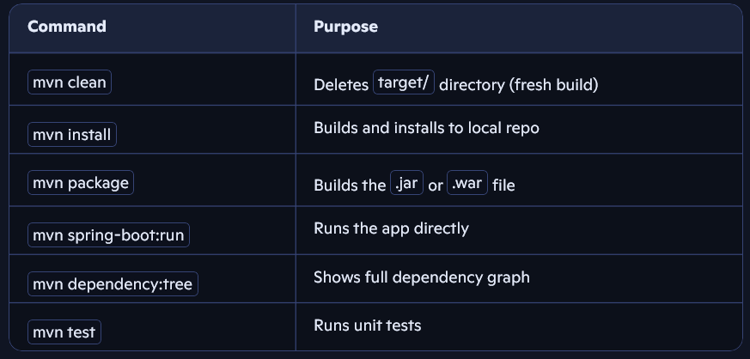

Governance Cue: Use dependency:tree to audit transitive dependencies and spot version conflicts

🧭 API Layer

6. Controllers
- Purpose: Handle HTTP requests and route them to service logic.
- Key Annotation: @RestController = @Controller + @ResponseBody
- Common Mappings:
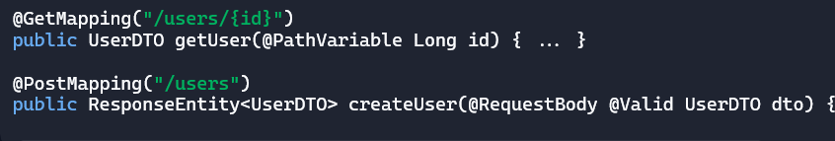
- Other Annotations:
  - @RequestParam, @PathVariable, @RequestBody, @ResponseStatus
  - @CrossOrigin – CORS support
- Governance Cue: Controllers define your API surface. Audit for REST consistency, validation, and exception handling.

7. DTOs (Data Transfer Objects)
- Purpose: Define clean, serializable API contracts.
- Why Use DTOs:
  - Avoid exposing internal entities.
  - Control field visibility and shape.
  - Enable versioning and transformation.
- Typical Structure:
- 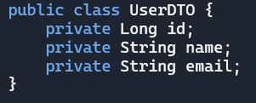
- Governance Cue: DTOs are your public-facing schema. Audit for field creep, versioning strategy, and mapping clarity.

8. Validation
- Purpose: Enforce constraints on incoming data.
- Key Annotation: @Valid on method parameters
- Common Constraints:
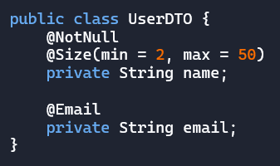
- Custom Validators:
  - Implement ConstraintValidator
  - Annotate with @Constraint(validatedBy = ...)
- Governance Cue: Validation protects your domain. Audit for missing constraints, silent failures, and error messaging.

🔄 Controller–DTO–Service Flow
Here’s a typical request flow:
Client → Controller → DTO → Service → Entity → Repository → DB
- Controller: Accepts request, validates DTO
- DTO: Defines request/response shape
- Service: Orchestrates logic
- Entity: Domain model
- Repository: Data access

🧠 Strategic Audit Tips
- Controllers:
  - Keep thin—delegate logic to services.
  - Use ResponseEntity for status control.
  - Centralize error handling with @ControllerAdvice.
- DTOs:
  - Version them if your API evolves.
  - Use MapStruct for clean conversion.
  - Avoid leaking entity fields (e.g., password, createdAt).
- Validation:
- Always annotate @Valid on controller methods.
- Use BindingResult to inspect validation errors.
- Customize messages for clarity and audit logs.

🛠️ Service Layer

9. Service Classes
- Purpose: Encapsulate business logic and orchestrate calls between repositories, mappers, and external systems.
- Key Annotation: @Service – Marks the class as a Spring-managed bean.
- Typical Structure:
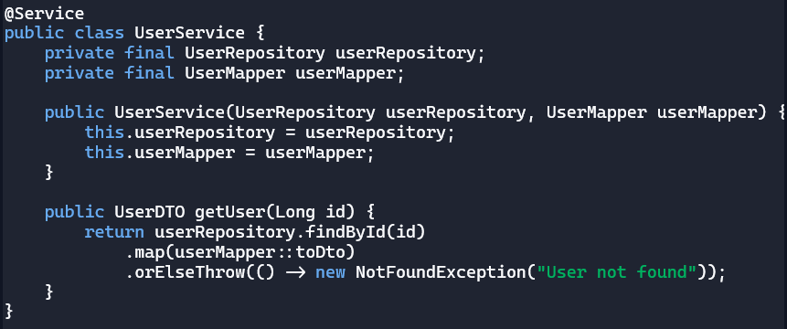
- Governance Cue: Services are your orchestration layer. Audit for:
- Business logic leakage into controllers or repositories
- Overloaded services (SRP violations)
- Missing transactional boundaries

10. Dependency Injection & Inversion of Control (IoC)
- Purpose: Spring manages object creation and wiring so you don’t have to.
- Types of Injection:
  - Constructor Injection (preferred):
  - Field Injection (less testable):
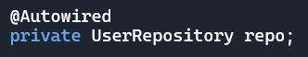
  - Setter Injection (used for optional dependencies):
- Inversion of Control (IoC):
  - You define what you need (@Component, @Service, etc.).
  - Spring decides how and when to instantiate and inject it.
- Governance Cue:
- Constructor injection = testable, explicit, immutable.
- Audit for tight coupling, hidden dependencies, and circular references.
- Use @Qualifier or @Primary to resolve ambiguity when multiple beans of the same type exist.

🔄 Service Layer in the Request Lifecycle

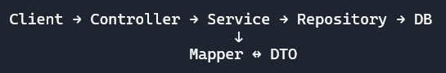

- Controller: Handles HTTP request/response.
- Service: Applies business rules, coordinates data flow.
- Repository: Fetches/persists entities.
- Mapper: Converts between DTOs and entities.

🧠 Strategic Audit Tips
- Service Design:
  - Keep services focused—1 domain = 1 service.
  - Avoid “God services” that do too much.
  - Use interfaces for testability and mocking.
- Dependency Injection:
  - Prefer constructor injection for immutability and clarity.
  - Avoid field injection in production code—harder to test and mock.
  - Use @Lazy to break circular dependencies if needed.
- Testing Services:
- Use @MockBean or @Mock + @InjectMocks with JUnit/Mockito.
- Test business logic in isolation from controllers and repositories.

🗃️ Persistence Layer

11. Repositories
- Purpose: Abstract data access using Spring Data JPA.
- Key Annotation: @Repository (optional if extending Spring Data interfaces)
- Typical Interface:
- Common Interfaces:
  - JpaRepository – full CRUD + pagination
  - CrudRepository – basic CRUD
  - PagingAndSortingRepository – adds paging/sorting
- Governance Cue: Repositories define query boundaries. Audit for:
- Overuse of custom queries
- Leaky abstractions
- Query method naming consistency

12. Entities
- Purpose: Represent domain models mapped to DB tables.
- Key Annotation: @Entity
- Common Annotations:
  - @Table(name = "users")
  - @Id, @GeneratedValue
  - @Column, @Enumerated, @Temporal
  - @OneToMany, @ManyToOne, @JoinColumn
- Example:
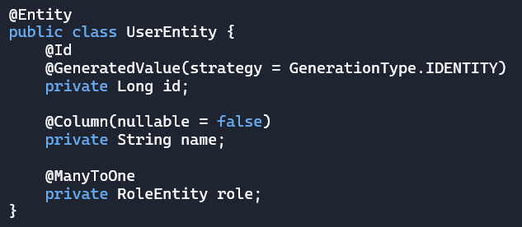
- Governance Cue: Entities are your schema mirror. Audit for:
- Field mismatches
- Lazy loading traps
- Bidirectional relationship complexity

13. Hibernate
- Purpose: ORM engine under JPA—handles SQL generation, caching, and lifecycle.
- Key Concepts:
  - Session: Hibernate’s unit of work
  - Lazy vs Eager Loading: Controls when relationships are fetched
  - Cascade Types: ALL, MERGE, REMOVE, etc.
  - Fetch Strategies: JOIN, SELECT, SUBSELECT
- Governance Cue: Hibernate is powerful but sneaky. Audit for:
- N+1 query issues
- Unintended cascades
- Misconfigured fetch plans

14. JPA Configuration
- Purpose: Configure how Spring Boot interacts with JPA/Hibernate.
- Common Properties:
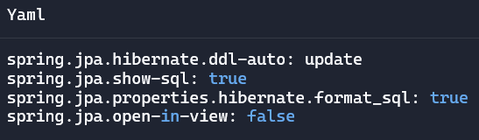
- DDL Strategies:
  - none, validate, update, create, create-drop
- Governance Cue: JPA config controls schema evolution. Audit for:
- Unsafe update/create-drop in production
- open-in-view causing lazy loading exceptions
- Logging verbosity and SQL visibility

15. Flyway
- Purpose: Manages versioned database migrations.
- Setup:
  - SQL scripts in /resources/db/migration
  - Naming: V1__init.sql, V2__add_user_table.sql
- Key Properties:
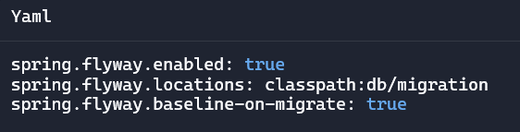
- Governance Cue: Flyway is your schema ledger. Audit for:
- Missing baselines
- Manual DB changes bypassing migration scripts
- Script naming and rollback strategy

🔄 Mapping & Conversion

16. MapStruct
- Purpose: Compile-time bean mapping between DTOs and entities.
- Key Annotation: @Mapper
- Typical Interface:
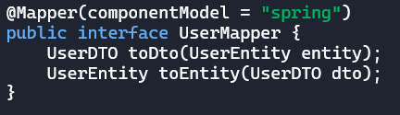
- Custom Field Mapping:
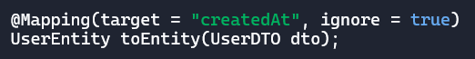
- Update Existing Object:
- Governance Cue: MapStruct generates traceable code. Audit for:
- Field mismatches
- Silent skips (ignore = true)
- Missing reverse mappings

MapStruct Setup (Maven)
- Dependencies:
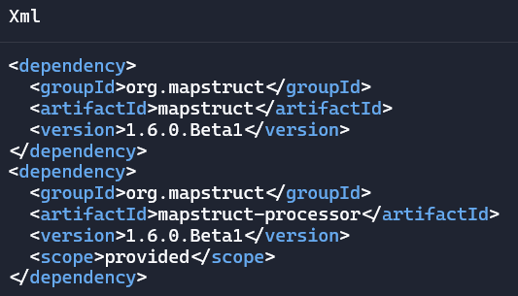
- Compiler Plugin: See Build & Dependency Management section.

17. Jackson
- Purpose: JSON serialization/deserialization for REST APIs.
- Key Annotation: @JsonProperty
- Common Annotations:
  - @JsonIgnore – Skip field during serialization
  - @JsonInclude(Include.NON_NULL) – Omit nulls
  - @JsonFormat – Format dates, enums
  - @JsonCreator – Custom constructor for deserialization
- Example DTO:
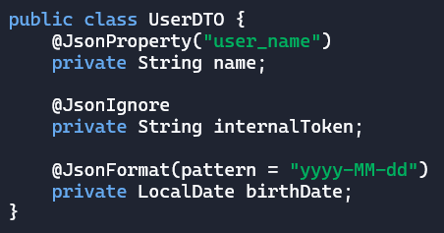
- Governance Cue: Jackson defines your API contract. Audit for:
- Field exposure risks
- Inconsistent naming
- Serialization surprises (e.g., nulls, dates, enums)

🔄 MapStruct vs Jackson
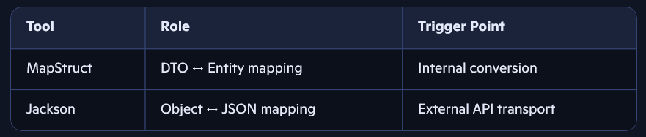
- MapStruct: Compile-time, type-safe, explicit.
- Jackson: Runtime, flexible, annotation-driven.

🔐 Security & Governance

18. Spring Security
- Purpose: Provides authentication and authorization for web apps and APIs.
- Key Concepts:
  - Authentication: Verifying identity (e.g., login)
  - Authorization: Controlling access (e.g., roles, permissions)
- Common Setup:
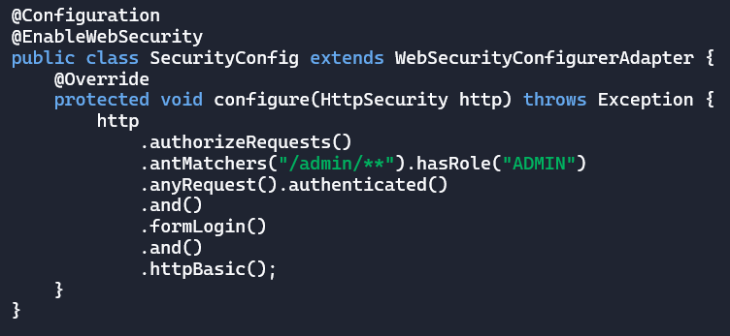
- Annotations:
  - @PreAuthorize("hasRole('ADMIN')")
  - @Secured("ROLE_USER")
- Governance Cue: Security config defines access boundaries. Audit for:
- Overexposed endpoints
- Missing role checks
- CSRF and CORS vulnerabilities

19. Audit Logging
- Purpose: Track system events, user actions, and data changes.
- Techniques:
  - Interceptors: Log incoming requests
  - Event Listeners: Track entity lifecycle events
  - Custom Loggers: Use SLF4J with MDC (Mapped Diagnostic Context)
- Example:
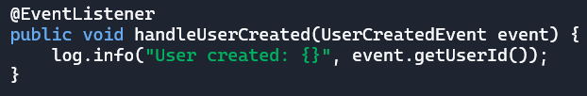
- Governance Cue: Audit logs are your forensic trail. Audit for:
- Missing context (e.g., user ID, timestamp)
- Inconsistent formats
- Lack of correlation IDs

20. Exception Handling
- Purpose: Centralize error handling and return meaningful responses.
- Key Annotation: @ControllerAdvice
- Typical Setup:

@ControllerAdvice
public class GlobalExceptionHandler {
@ExceptionHandler(NotFoundException.class)
public ResponseEntity<String> handleNotFound(NotFoundException ex) {
return ResponseEntity.status(HttpStatus.NOT_FOUND).body(ex.getMessage());
}

@ExceptionHandler(MethodArgumentNotValidException.class)
public ResponseEntity<String> handleValidation(MethodArgumentNotValidException ex) {
return ResponseEntity.badRequest().body("Validation failed");
}
}
Governance Cue: Exception handling defines your failure contract. Audit for:
- Leaky stack traces
- Inconsistent status codes
- Missing validation feedback

🧠 Strategic Audit Tips
- Security:
  - Use BCryptPasswordEncoder for password hashing.
  - Disable default /login if using custom auth.
  - Validate JWT tokens if using stateless auth.
- Audit Logging:
  - Use MDC to inject requestId, userId, etc. into logs.
  - Log both success and failure paths.
  - Consider structured logging (JSON format) for log aggregation tools.
- Exception Handling:
- Return consistent error formats (e.g., {code, message, timestamp})
- Avoid exposing internal exception types to clients.
- Use custom exceptions for domain-specific errors.

🧪 Testing & Debugging

21. Unit Tests
- Purpose: Test individual components (e.g., services, mappers) in isolation.
- Frameworks: JUnit 5, Mockito
- Typical Setup:
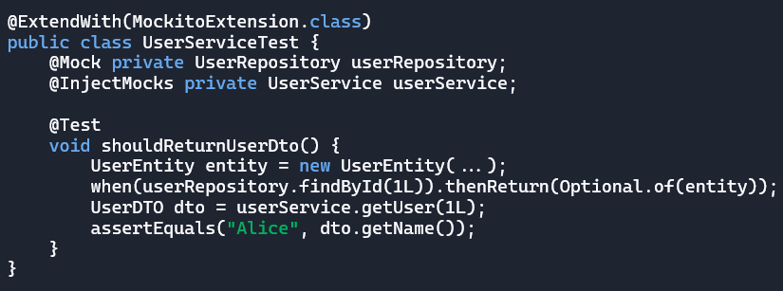
- Governance Cue: Unit tests validate logic boundaries. Audit for:
- Missing edge cases
- Overuse of mocks
- Lack of assertions

22. Integration Tests
- Purpose: Test multiple layers together (e.g., controller → service → repository).
- Framework: Spring Boot Test (@SpringBootTest)
- Typical Setup:
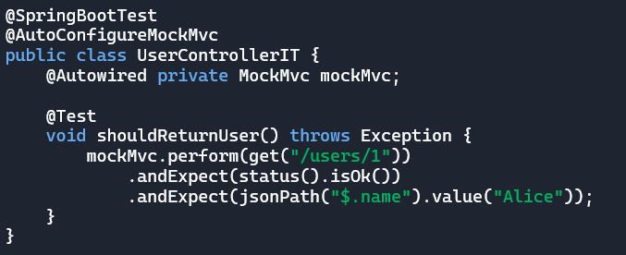
- Specialized Tests:
  - @WebMvcTest – controller-only
  - @DataJpaTest – repository-only
- Governance Cue: Integration tests validate system flow. Audit for:
- Missing DB setup
- Fragile test data
- Overlapping test scopes

23. Logging
- Purpose: Trace execution, capture errors, and support debugging.
- Frameworks: SLF4J (API), Logback (implementation)
- Typical Usage:
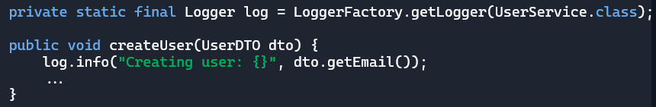
- Log Levels:
  - TRACE – fine-grained debug
  - DEBUG – dev-level diagnostics
  - INFO – business events
  - WARN – recoverable issues
  - ERROR – serious failures
- Governance Cue: Logs are your runtime audit trail. Audit for:
- Missing context (e.g., user ID, request ID)
- Overuse of DEBUG in production
- Leaky stack traces

🧠 Strategic Audit Tips
- Unit Tests:
  - Use @Mock + @InjectMocks for isolation.
  - Cover happy path + edge cases.
  - Avoid testing framework behavior (e.g., mocking List.add()).
- Integration Tests:
  - Use test containers for DB isolation.
  - Reset state between tests.
  - Use @Sql or Flyway for schema setup.
- Logging:
- Inject correlation IDs using MDC.
- Use structured logging for log aggregation tools (e.g., ELK, Grafana).
- Avoid logging sensitive data (e.g., passwords, tokens).

🚀 DevOps & Delivery

24. Actuator
- Purpose: Exposes operational endpoints for monitoring and diagnostics.
- Key Dependency:
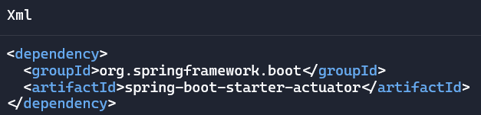
- Common Endpoints:
  - /actuator/health – app health
  - /actuator/info – metadata
  - /actuator/metrics – JVM, HTTP, DB stats
  - /actuator/env – environment variables
- Enable Specific Endpoints:
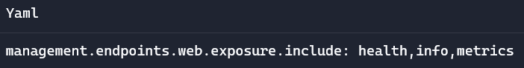
- Governance Cue: Actuator is your runtime dashboard. Audit for:
- Overexposed endpoints
- Missing health indicators
- Lack of integration with monitoring tools (e.g., Prometheus)

25. Dockerization
- Purpose: Package your app into a portable container.
- Typical Dockerfile:
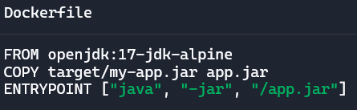
- Build & Run:
- 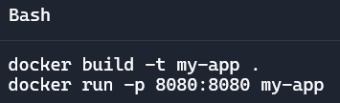
- Governance Cue: Docker defines your runtime boundary. Audit for:
- Missing .dockerignore
- Hardcoded secrets
- Unoptimized image layers

26. CI/CD Pipelines
- Purpose: Automate build, test, and deployment workflows.
- Common Tools:
  - GitHub Actions
  - Jenkins
  - GitLab CI
  - Azure DevOps
- Typical GitHub Actions Workflow:
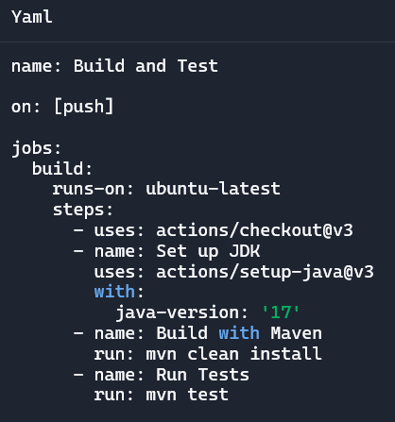
- Governance Cue: Pipelines enforce delivery discipline. Audit for:
- Missing test stages
- Manual deployment steps
- Lack of rollback or failure notifications

🧠 Strategic Audit Tips
- Actuator:
  - Use /actuator/health for readiness probes in Kubernetes.
  - Customize health indicators (e.g., DB, disk space).
  - Secure sensitive endpoints with Spring Security.
- Docker:
  - Use multi-stage builds for smaller images.
  - Externalize config via environment variables.
  - Tag images with version and commit hash.
- CI/CD:
- Include static analysis (e.g., SpotBugs, Checkstyle).
- Use secrets management (e.g., GitHub Secrets, Vault).
- Automate rollback on failed deploys.

🏷️ Annotation Index

🔧 Core & Configuration
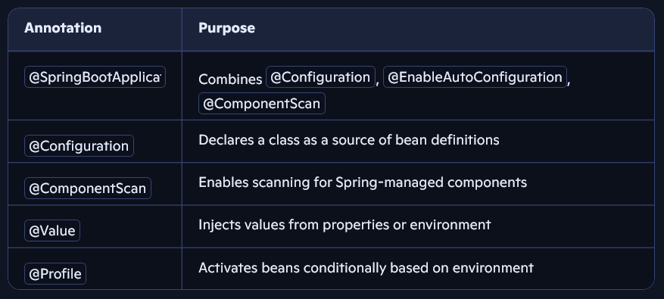

🧭 API Layer
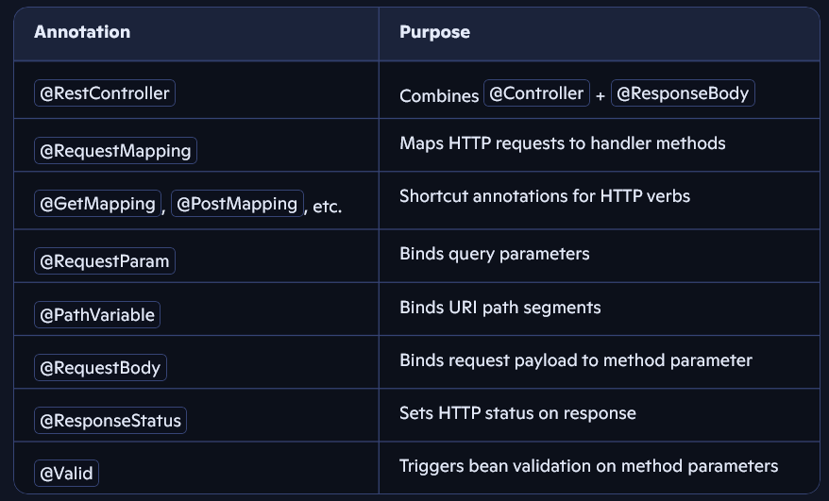

🛠️ Service & Injection
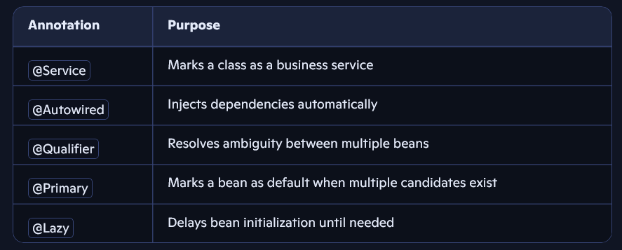

🗃️ Persistence & ORM
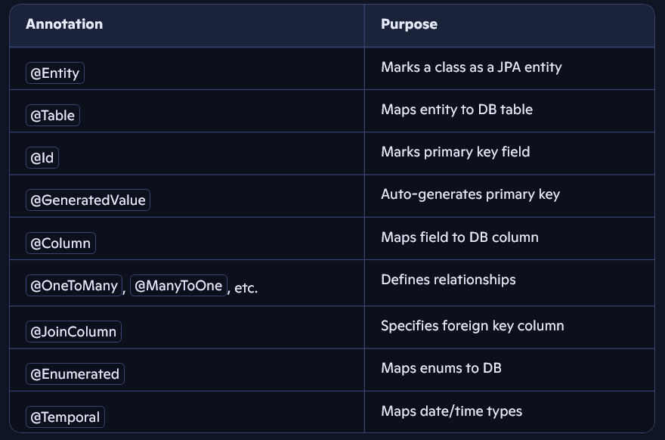

🔄 Mapping & Serialization
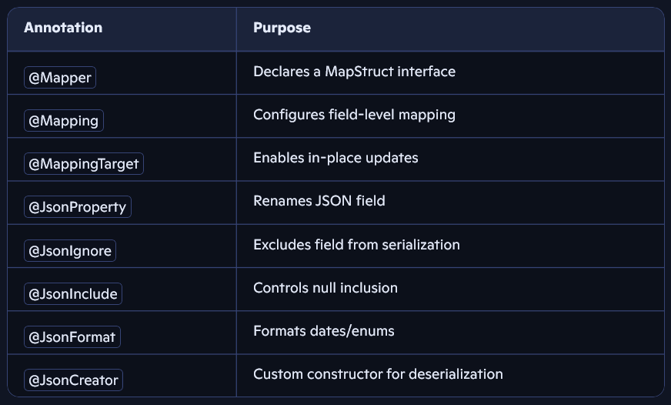

🔐 Security & Governance
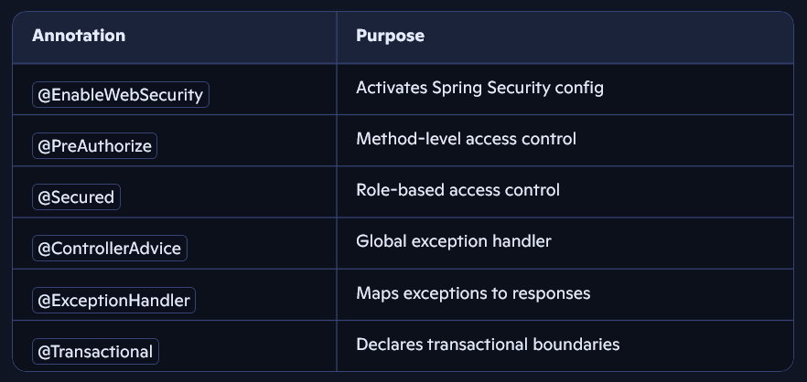

🧾 Spring Boot Ecosystem Overview
ddd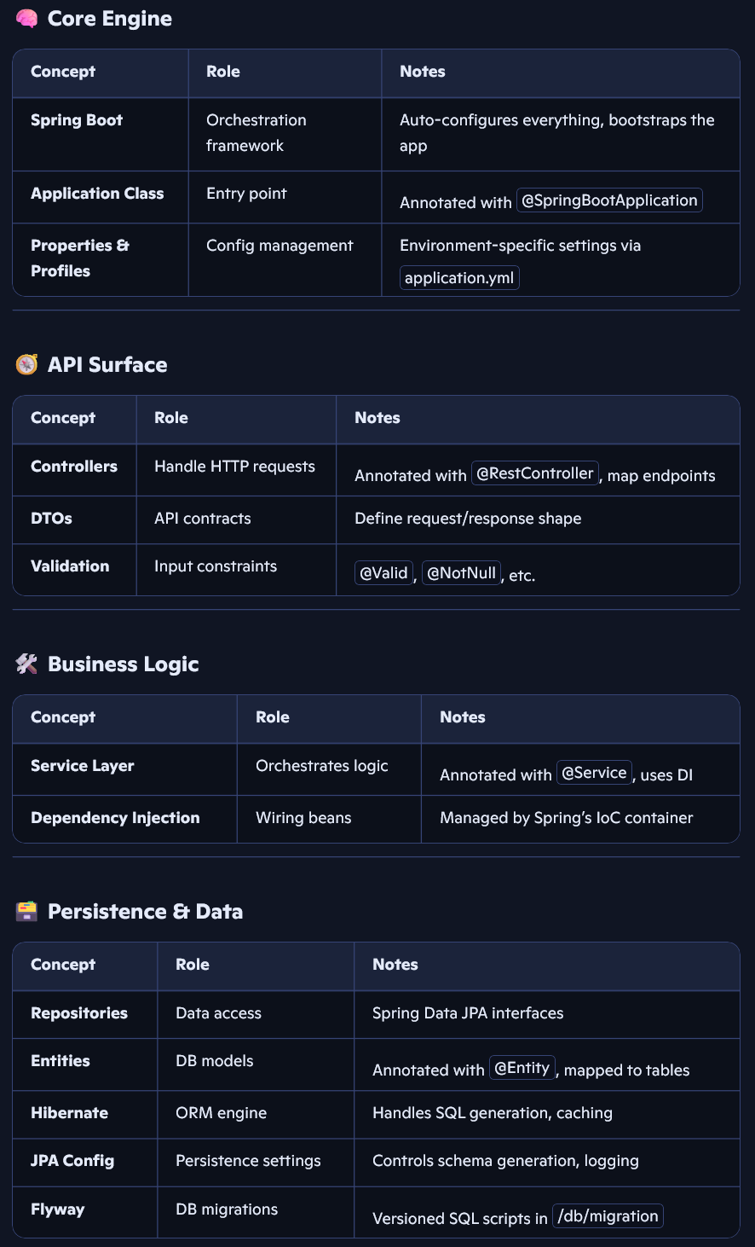 | 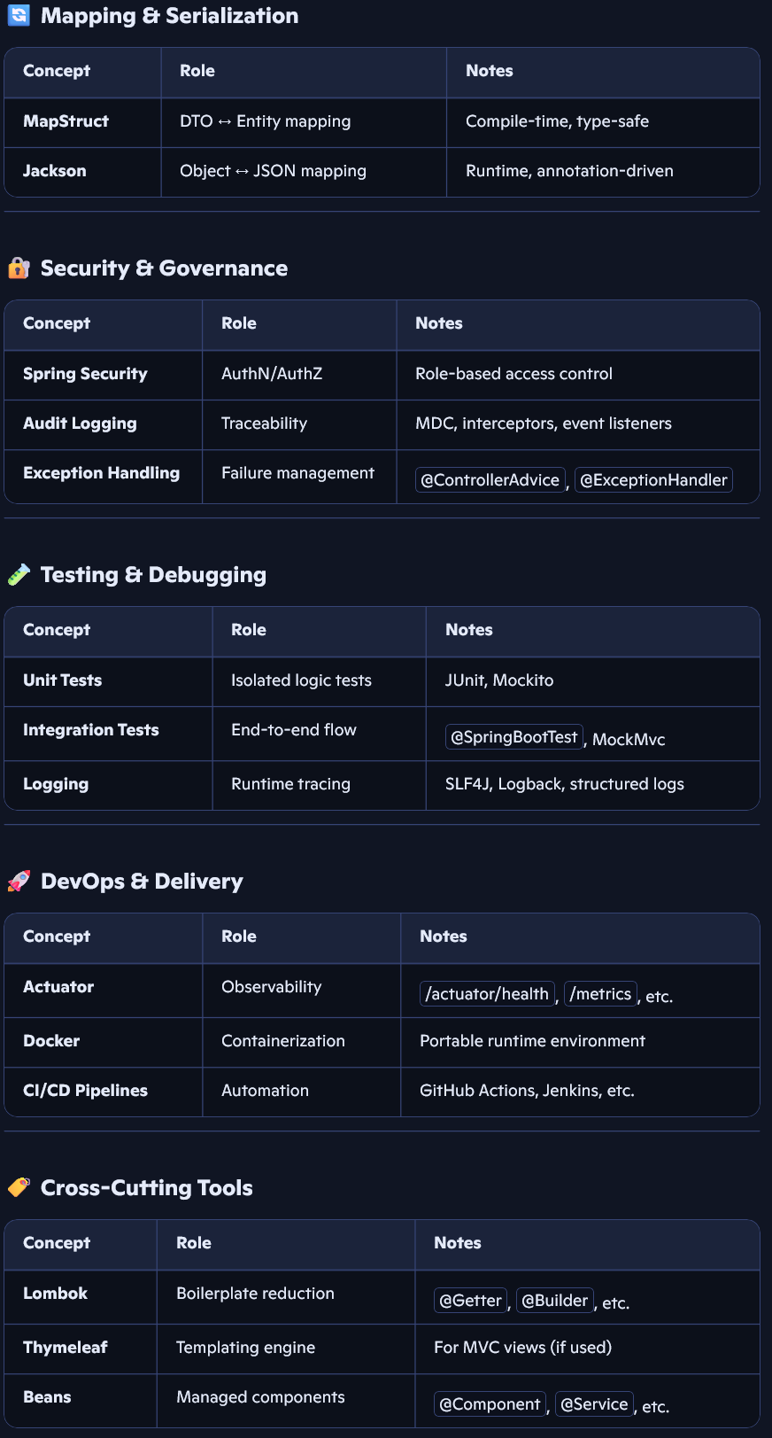

Java Collections
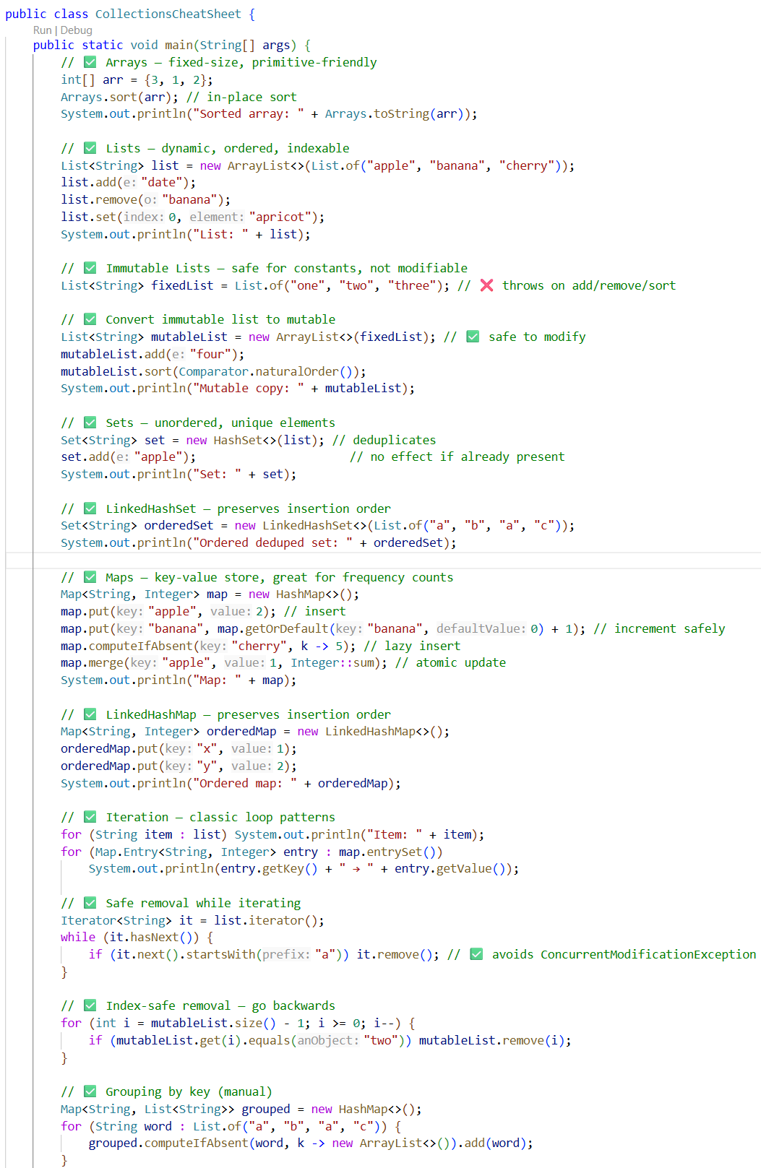
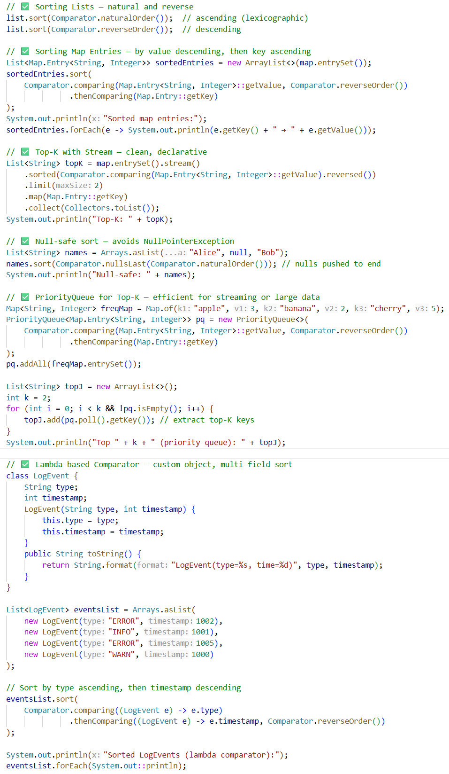

Java Date and Time
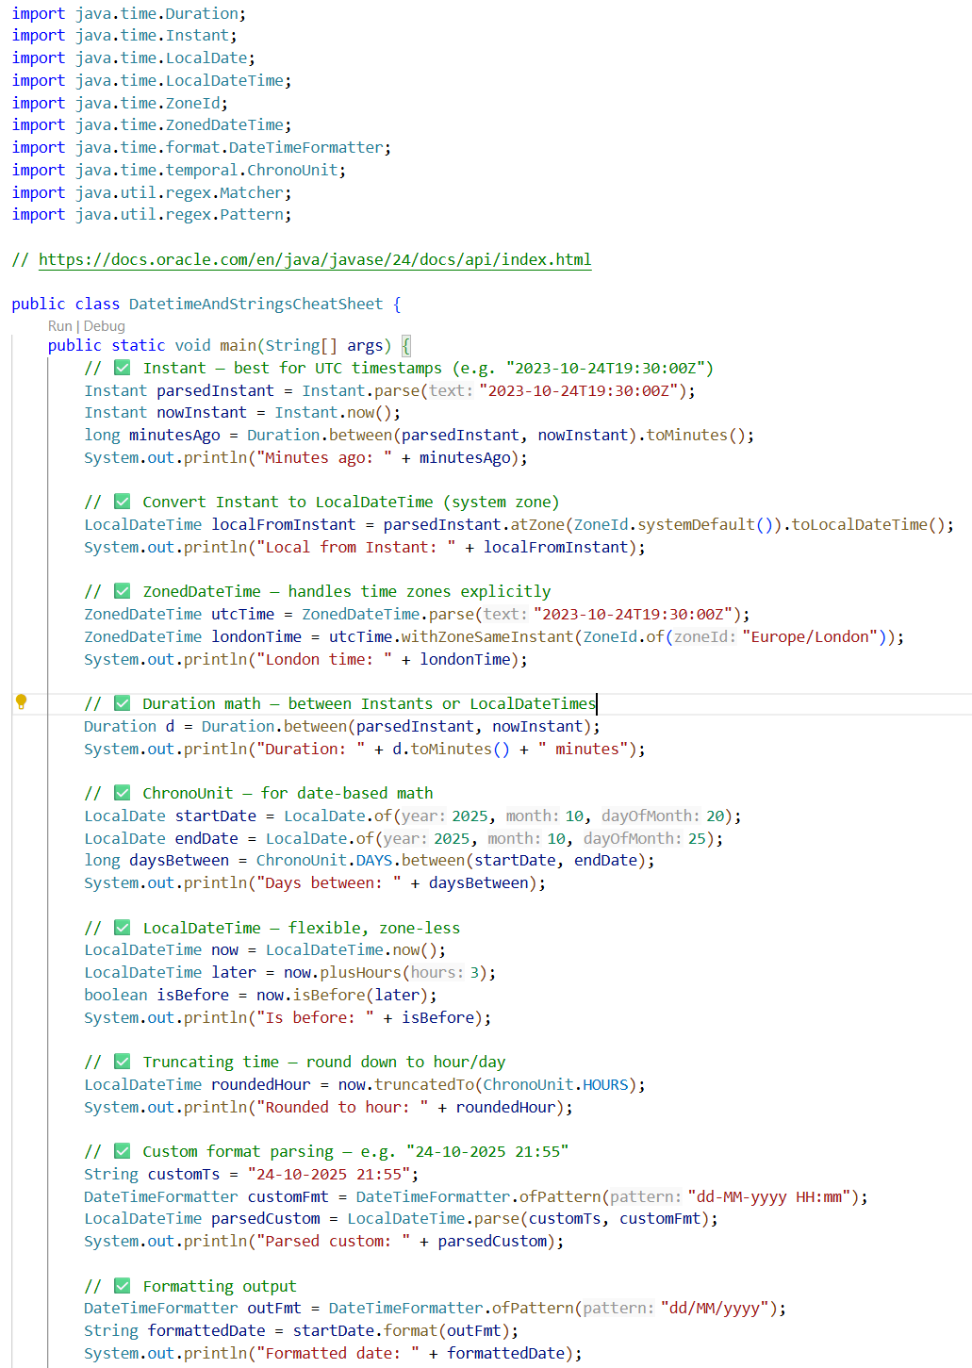

Java Strings
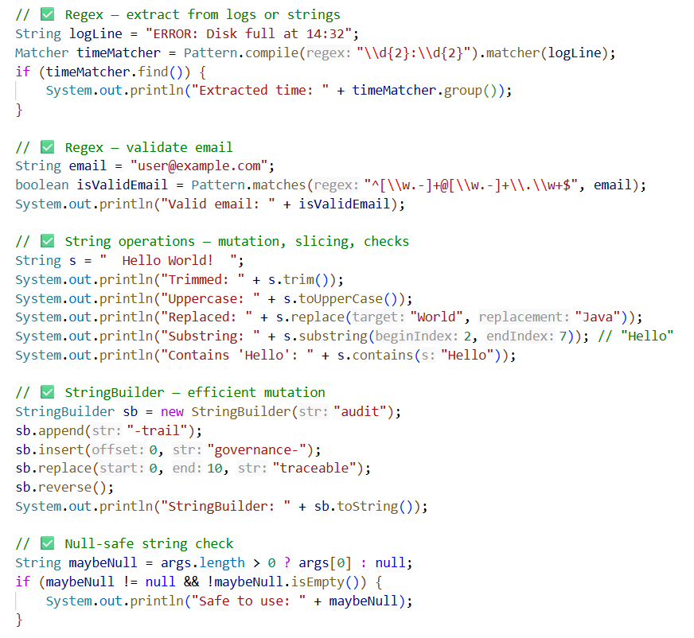

Java Recursion
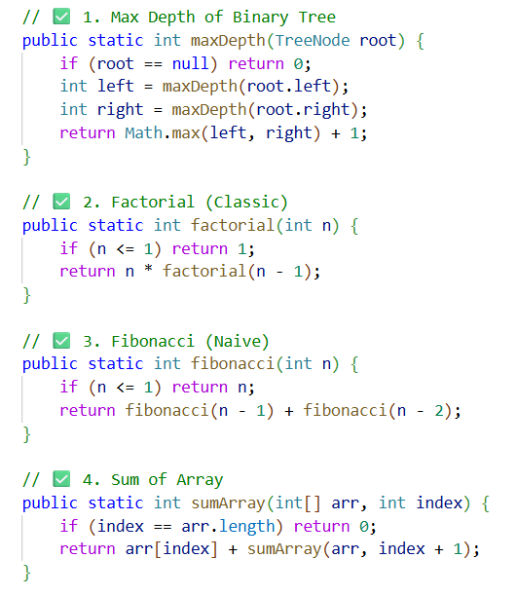 | 